ROLL NO:213064

NAME:KHANSA.

MID EXAM

QUESTION NO :6

CODE:

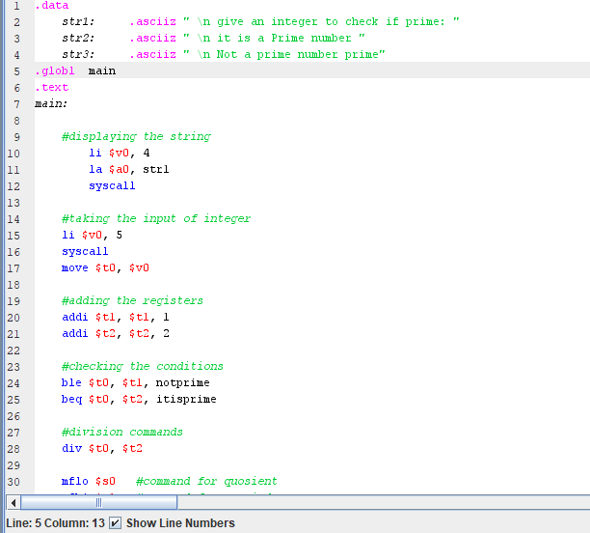

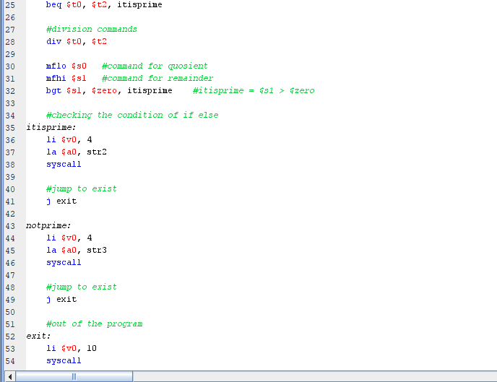

OUTPUT :

